**FULL-STACK ASSIGNMENT**

**Module 1**

Software Development Life Cycle (SDLC)

**INSTITUTION**



**SUBMITTED BY**

Rinesh Unnikrishnan

**SUBMITTED TO**

Tanvi Meer

1. **What is software? What is software engineering?**

* Software is a set of programs (sequence of instructions) that allows the user to perform a specific task or a well-defined function. The software can be divided into two main categories:

1. System/Operating Software
2. Application Software
3. Programming Software

* Software engineering is an engineering branch associated with the development of software products using well-defined scientific principles, methods, and procedures.
* Software engineering is the art of developing quality software on time and within budget.
* It is a systematic approach to software system design, development, operation, and maintenance.

1. **Explain types of software.**

* There are three types of software :
* System Software  
  System software provides the basic functions for computer usage and helps to run the computer hardware and system. It is the software used by that computer to translate inputs from various sources into a language that a machine can understand. It coordinates the different hardware components of a computer.

Ex: Linux, window, macOS, Android, iOS

* Application Software

This is the program designed to make the user make more productive and assist them with personal tasks. Types of application software

1) Mobile app

2) Desktop app

3) Web app

* Programming Software

Programming software is the process of designing, writing, testing, debugging, and maintaining the source code of computer programs. This software is written in a programming language.

The purpose of programming is to create a program that exhibits a certain desired behavior.

1. **What is SDLC? Explain each phase of SDLC?**

* SDLC (Software Development Life Cycle):SDLC is a structure imposed on the development of a software product that defines the process for planning, designing, implementation, testing, deployment, and ongoing maintenance and support.

1. Planning phase:

SDLC is a structure imposed on the development of a software product that defines the process for planning, implementation, testing, documentation, deployment, and ongoing maintenance and support

* SDLC is a structure imposed on the development of a software product that defines the process for planning, implementation, testing, documentation, deployment, and ongoing maintenance and support

1. Designing phase:

During the design phase, lead developers and technical architects create the initial high-level design plan for the software and system. This includes the delivery of requirements used to create the Design Document Specification (DDS). This document details database tables to be added, new transactions to be defined, security processes, as well as hardware and system requirements.

1. Implementation phase:

-In this phase, the database admin creates and imports the necessary data into the database. Programming languages are defined by requirements. Developers create the interface as per the coding guidelines and conduct unit testing. This is an important phase for developers. They need to be open-minded and flexible if any changes are introduced by the business analyst.

1. Testing phase:

Testers test the software against the requirements to make sure that the software is solving the needs addressed and outlined during the planning phase. All tests are conducted as functional testing, including unit testing, integration testing, system testing, acceptance testing, and non-functional testing.

1. Deployment phase:

After successful testing, the product is delivered/deployed to the client, and even clients are trained on how to use the product.

1. Maintenance and support phase:

In a post-production, live software environment, the system is in maintenance mode. No matter the number of users, the sophistication of the software, and rigorous QA testing, issues will occur. That’s the nature of software with managing data, integration, security, and real-world usage. Access to knowledgeable, reliable support resources is essential, as is routine maintenance and staying up to date on upgrades.

1. **What is DFD? Create a DFD diagram on Flipkart.**

* DFD is a traditional way to visualize the information flows within a system. A neat and clear DFD can depict a good amount of the system requirements graphically. It can be manual, automated, or a combination of both.
* DFD Diagram for Flipkart

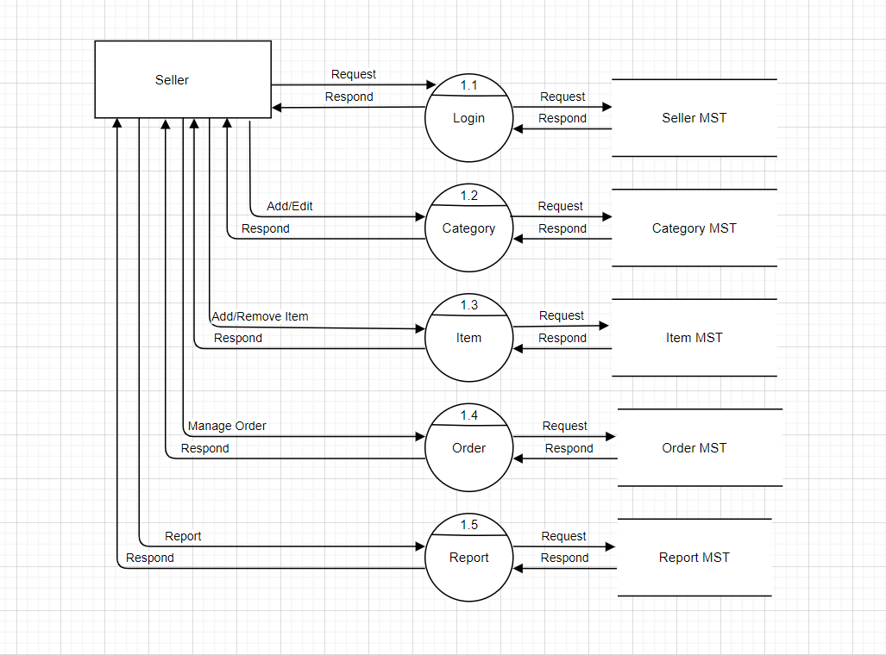

1. **What is a Flow chart? Create a flowchart to make the addition of two numbers.**

* A flow chart is a graphical or symbolic representation of a process. Each step in the process is represented by a different symbol and contains a short description of the process step. The flow chart symbols are linked together with arrows showing the process flow direction.
* Flowchart for the addition of two numbers:

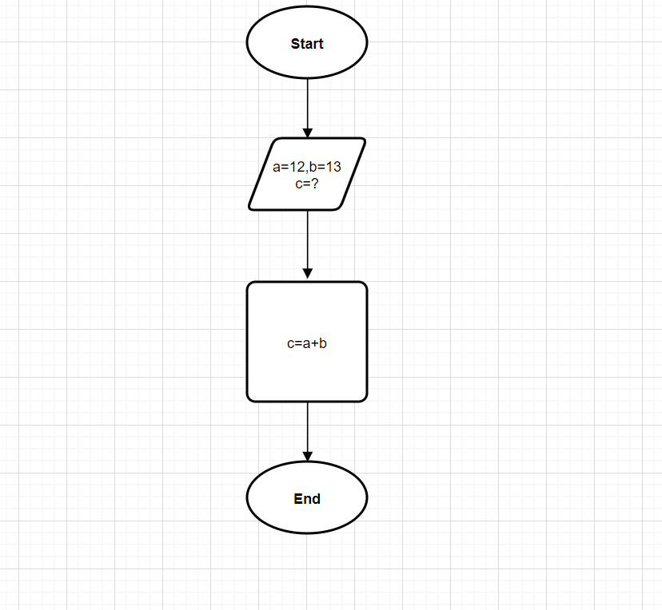

1. **What is a Use case Diagram? Create a use-case on the bill payment on Paytm.**

* A use case diagram is used to represent the dynamic behavior of a system. It encapsulates the system's functionality by incorporating use cases, actors, and their relationships. It models the tasks, services, and functions required by a system/subsystem of an application. It depicts the high-level functionality of a system and also tells how the user handles a system.\
* Use-case on the bill payment on Paytm:

